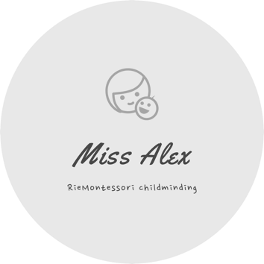

HOURS

At RieMontessori, we offer full-day sessions for children from 1 to 3 years old.
I provide care Monday to Thursday 8:00am - 4:00pm. We are open 44 weeks of the year excluding some of the bank holidays.

Flexibility: If you want to drop off later or pick up earlier you can do so, but you will need to inform me by text or phone call. To allow your child to be part of the daily programme please avoid arriving with your child later than 8:30 am or picking up earlier than 3:30 pm.

FEES

£108 per day
Hours: 8:00am – 4:00pm

The fee includes care, meals, resources, equipment, trips, and outings.
To give your child, the best care and to settle comfortably, I ask for a minimum of 3 days attendance per week.

RieMontessori’s ethos is built around the Montessori Method of education and as such I strongly advocate that children attend a minimum of 4 sessions/days in order that a child can fully benefit from the environment, the Montessori work cycle and form relationships.

Fees are reviewed annually in September.

GOVERNMENT FUNDING

Tax Free Childcare Scheme

I am registered with the gov.uk tax free childcare scheme. To find out if you’re eligible and make an application visit https://www.gov.uk. For working families, including the self-employed, in the UK: every £8 you pay into an online account, the government will add an extra £2, up to £2,000 per child per year.

Funding

I offer funded places and I am accepting early education funding childcare vouchers.

OVERVIEW OF FEES AND PLANS

 | FEE PER MONTH
 | 2 days | 3 days | 4 days
Full Day | £918** | £1,377 | £1,836

*Fees are calculated as "fee" * "number of days per week" * 4.25. Fees are equated out to 12 equal monthly instalments (so 4.25 weeks each month). All fees are subject to review and updated on annual basis.
**Available for the first month only.

LATE PICKUP FEE

Unfortunately, I need to charge a late pick up fee. You will have a 5 minutes grace period but after this I will have to charge £10 per each 10 minutes you are late.

PAYMENT TERMS

A deposit equal to two months of fees based on the number of days agreed is required upon registration to hold the place for your child. Half of this deposit will then be used as your first month’s fee, when the contract commences and half of it will be kept as a retainer fee, which will be repaid to you when your child leaves the setting and the four weeks written notice was given.

In the event that you later decide not to take up the place, the deposit is non-refundable. I require payments in advance so you will receive an invoice for the following month’s fees, which must be paid prior to commencement of the month.

Unfortunately, I am not able to refund you if your child is sick or for holidays.

CANCELLATIONS
If you wish to cancel your child's place with RieMontessori or decrease the number of days attending, you will need to give me 1 months’ notice (i.e. cancelling a place in August means you must give notice by 30th June). The notice period does not include the holidays (the 7 weeks when the setting is closed). You must put this cancellation in writing to riemontessorichild@gmail.com

